City of Senoia, Georgia
Request for Proposals
for
Livable Centers Initiative Study

Issue Date: October 7, 2022
Issued By: City of Senoia
Office of the City Manager
80 Main Street
Senoia, GA 30276

Inquiries: Jeff Fisher, Assistant City Manager
City of Senoia
jfisher@senoia.com

Proposals Due: November 18, 2022 by 12:00 PM EST
Bid Opening: November 18, 2022 by 12:00 PM EST

FACT SHEET

Title of RFP: | Livable Centers Initiative Study
Date of Issue: | October 7, 2022
Last day to submit questions: | October 14, 2022
Date of final answers: | October 21, 2022
Proposal due date: | November 18, 2022
Copies of proposal required: | 1 original, 5 copies plus 1 digital copy
Proposal opening date: | October 7, 2022
Proposal submission location: | Senoia City Hall, Office of the City Manager
Proposal opening location: | Senoia City Hall, Office of the City Manager
Project name: | Livable Centers Initiative Study
Site location/Size: | Senoia, GA
Funding source: | City of Senoia – ARC Matching
Firm selection schedule: | Target date of December 5, 2022 or ASAP

INSTRUCTIONS FOR PROPOSALS

Written responses to all written inquiries received by 12:00 PM ET, October 14, 2022 will be posted on the City’s website at www.senoia.com under bid opportunities, Livable Centers Initiative Program , as an addendum. It is the Candidate’s responsibility to follow this bid process so that they will be aware of all addenda being posted prior to bid opening. Acknowledgement of all addenda is required. No City staff or other officials associated with this RFP should be contacted regarding this RFP other than the City Official named below. Doing so may result in disqualification.

All inquiries regarding this RFP Must be in writing via email and addressed to:

Jeff Fisher, Assistant City Manager
jfisher@senoia.com

An original, five (5) copies and one (1) digital copy of this RFP are to be submitted to:

Harold Simmons
Senoia City Manager
80 Main Street
Senoia, Georgia 30276

Proposals must be submitted no later than 12:00 PM EST, November 18, 2022. Proposals may be opened by City at any time after the submission deadline. All proposals satisfying the requirements of this Request for Proposal will be evaluated to establish which of the Candidate(s) best fulfills the needs of the City and this project. Proposals must be received in an envelope or container marked “Competitive Proposals for “Livable Centers Initiative Program””. Place the Project name, and opening date on the submitting envelope or container.

CITY OF SENOIA, GEORGIA
A. Purpose
The purpose of the Study is to develop a Unified Development Code (UDC), and develop a Comprehensive Multi-Modal Transportation Circulation plan that identifies opportunities to improve a safer circulation within the area of study. The circulation plan should focus on enhancing pedestrian circulation, transit, bike, and non-auto accessibility to the downtown center and improving road connectivity. For the purpose of the RFP, the Candidate is to provide a detailed work plan describing the process and the methodology to be employed in deriving the information requested. The City of Senoia anticipates refinement of the final scope of services based on additional information contained in the responses to this RFP and/or information from the presentations made to the City of Senoia by the finalists.
B. Background
The City of Senoia has been awarded Livable Centers Initiative (LCI) funds ($250,000.00), at an 80/20 matching on behalf of the Senoia Community, to enhance transportation and pedestrian connectivity from the downtown center to surrounding neighborhoods. The Town Center Catalytic Study will include potential development of a network of multimodal connections to the town center from the rest of the city through multi-use paths and innovative street design and revised development guidelines.
C. Livable Centers Initiative Program Requirements
The Livable Centers Initiative (LCI) includes general goals intended to link transportation and land use, increase housing options, promote mixed-use development, expand transportation choice, and encourage thoughtful economic growth.
Projects funded through the Livable Centers Initiative Program use competitive procurement procedures and follow applicable Federal regulations (49 CFR Part 18). Contracts executed for completion of this project must comply with the Georgia Security and Immigration Compliance Act as prescribed in O.C.G.A. Section 13-10-91. Additionally, Disadvantaged Business Enterprise (DBE) requirements of 49 CFR Part 26 applies to LCI projects since federal funds are utilized. It is a City of Senoia objective to ensure that DBEs have an equal opportunity to participate in the project. Consultants are encouraged to involve DBEs in all aspects of work.
D. General Information
All products developed for the purpose of this planning project (studies, graphics, etc.) and delivered to the City shall become the sole property of the City.
E. Proposal Format
The Candidate shall prepare responses according to the RFP format by Scope of Work section. The City reserves the right to reject any RFP not submitted within the required time frame; reject any incomplete RFP submitted; contact references whether listed in the response or not; require further information; and/or require interviews with any corresponding Candidates. All costs related to the preparation, submittal, and/or presentation of this RFP are the responsibility of the Candidates and will not be assumed in full or in part by the City. Issuance of this RFP does not constitute a commitment on the part of the City to award a contract pursuant to this RFP. The City further reserves the right to make changes to this RFP at any time by issuance of written addendum or clarifications.
Packaging of Proposal
Number of Copies
One (1) original and five (5) printed copies of the submittal
One (1) electronic copy (pdf format) submitted on a Flash Drive
Clear and concise Transmittal Letter
Proposal must be on 8 1/2" x 11" paper with pages numbered
Table of contents with corresponding tabs must be included to easily identify each section
Deadline for Submission
Proposals should be received no later than November 18, 2022 by 12:00 p.m. (noon) EST.
Preparation of Proposal
Each Candidate will be asked to submit detailed information concerning their experience and abilities.
The City reserves the right to negotiate, prior to award, adjustments in any and all elements of what the Candidate submits in their proposals.
Any submitted proposal shall remain valid for 60 days after the proposal due date or until the City executes a contract, whichever is sooner. The City may, in the event the selected Candidate fails to perform and/or the contract is terminated within forty-five days of its initiation, request the Candidate submit the next acceptable proposal to honor its proposal.
F. Selection Criteria and Evaluation Information
Qualification of Team
Particular attention will be given to teams with the following: team make up including a certified planner and/or a land use attorney; extensive experience in authoring codes that employ smart growth principles.
Identify the team lead and include a resume (1 page maximum).
Specialized Experience
Background experience particularly with municipalities completed within the last five (5) years (5 pages maximum). For each project listed, provide an owner reference email and contact number.
Record of Implementation Ability
Experience in the public participation process to build constituencies for implementation; developing plans and implementation tools and techniques intended to achieve the goals and objectives of the plans; Unified Development Code.
Effective Outreach
Clear demonstration of prior experience conducting effective outreach to elected and appointed officials.
Quality of Performance History
Demonstration of effective cost control, work quality, adherence to schedules/deadlines.
Georgia Experience/Knowledge; Coweta County
Knowledge of key planning issues and influences impacting Coweta County.
Flexibility and Creativity
Special attention will be given to teams who express a clear understanding in drafting and implementing flexible ordinances that may be tailored to a Comprehensive Plan and easily adopted in areas with limited local capacity. Attention will be given to teams that lay out a creative and meaningful plan of action.
Financial Stability of Candidate
(1) Year Company was established; (2) billings for the last three years (including the current fiscal years); (3) listing and description of all litigation history; (4) most recent year's audited income statement and balance sheet.
A selection committee will determine the Candidate’s to be the most qualified. Interviews may be conducted with the top ranked companies on the shortlist. The selection committee will submit a recommendation to the City following the interviews (if held).
The selection committee will use the following merit-based rating system:
(1) Staffing - Evaluation of Project key members qualifications and experience [20 points].
(2) Experience/Performance - Review of past performance on similar projects and client references [40 points].
(3) Approach - Evaluation of overall understanding of the project scope; this should include a preliminary Project schedule by task and milestones that will be used in the process to complete the requested study. Provide in detail the services the Offeror will be providing [25 points].
(4) Availability - Evaluation of workload, schedule and office location(s) [5 points].
(5) Financial Stability - Evaluation of overall financial position [10 points].
Interview - a maximum of twenty (20) additional points will be awarded based on the overall presentation and performance of the interview (If held).
Maximum Points possible equals 100 points, unless interview is required; maximum 120 points.
A short list of the top six (6) candidates will be reviewed by the selection committee.
G. Project Boundary
Character Map - Geographic boundary map of LCI area of study is to include the entire city limits.
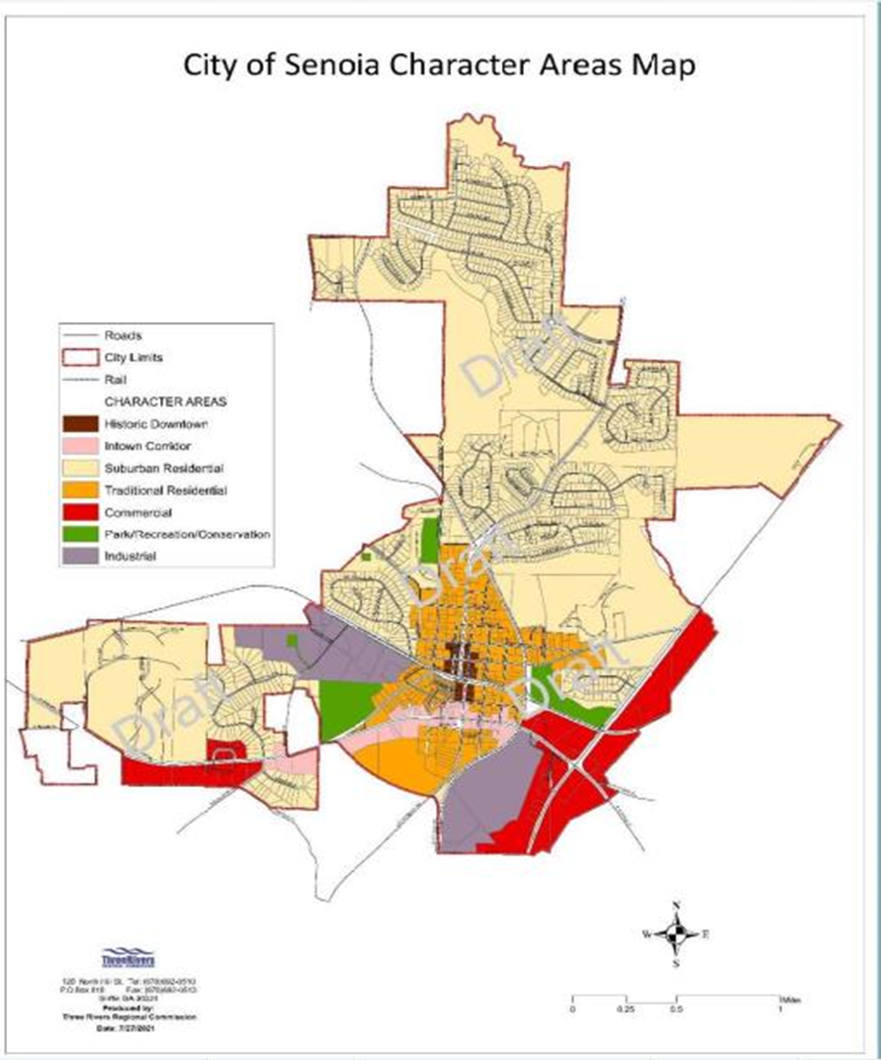

Zoning Map - Geographic boundary map of LCI area of study is to include the entire city limits.
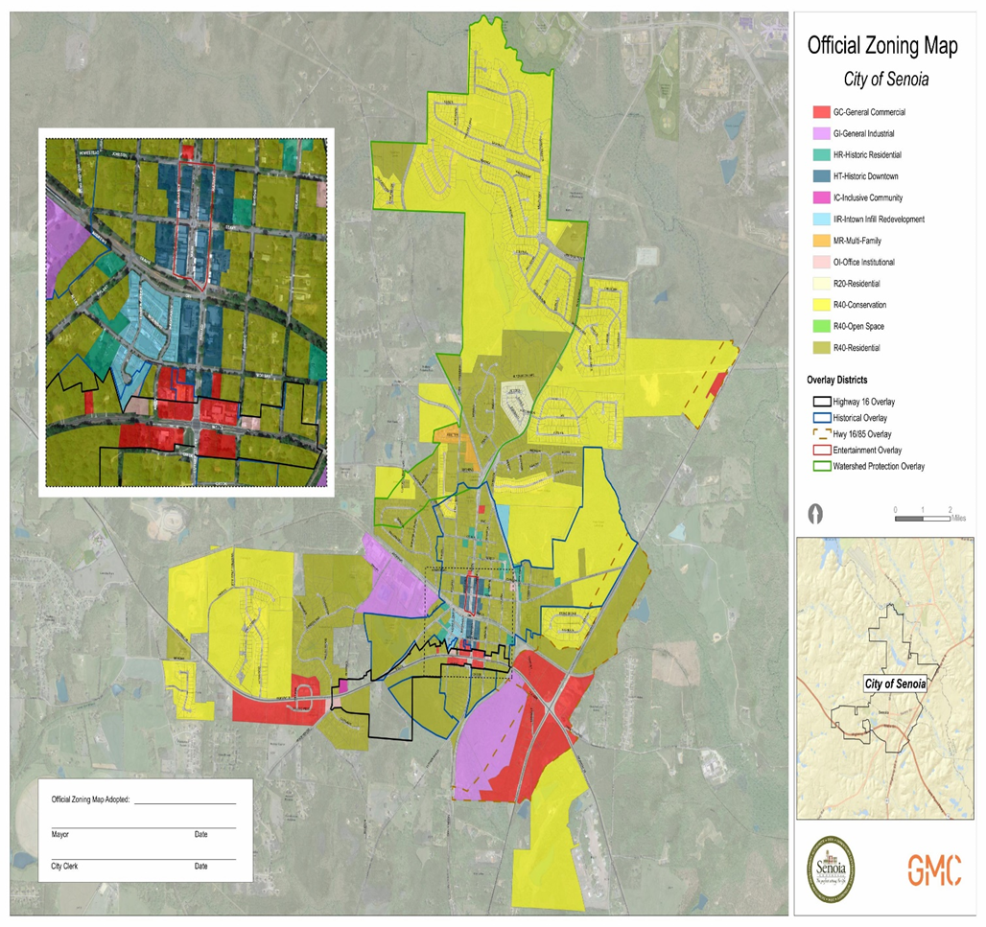

Code of Ordinances: https://library.municode.com/ga/senoia/codes/code_of_ordinances
City Comprehensive Plan: https://www.senoia.com/documents
Zoning Map: https://www.senoia.com/documents

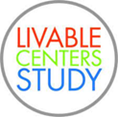
H. Scope of Services
The City of Senoia is seeking professional services to conduct a thorough review and analysis of its Development Guidelines and Comprehensive Plan, and to produce a Unified Development Code and Unified Multi-Modal Development Plan that focuses on safely connecting the historic downtown to surrounding neighborhoods. This will be conducted through informed analysis and a public process.
The Candidate’s should describe the specific processes that will be used to accomplish each of the tasks described below.
I. General: The work to be accomplished is in support of the following Atlanta Regional
Commission (ARC) 202CAS - Livable Centers Initiative Investment Policy Studies (LCI).
II. Area covered: All the necessary services provided in this subgrant contract will support the
study of LCI-related programs and projects within the Senoia LCI area as proposed in
Exhibit A- (Staff to add map).
1. The study area may extend beyond these limits if needed for logical termini purposes.
III. Goal: Portions of the Atlanta Metropolitan Transportation Planning Area are in maintenance
for both ozone and PM2.5 standards under the Clean Air Act Amendments of 1990. Because of
this designation, the region must look toward better development practices that support increased
use of transportation modes other than single occupant vehicles (SOV) to help reduce emissions
and meet air quality requirements. The LCI Program seeks to increase the use of alternatives to
driving alone by developing transportation projects and other programs to improve accessibility,
expand mixed-uses, utilize transit, and support further development in the study area. Evaluation
of the existing structure and development of likely scenarios should produce recommendations
for future investment that supports ARC’s Livable Centers Initiative Program. Improving safety and walkability will result in the increases in the alternatives to driving alone.
IV. Work Tasks
The City of Senoia (Sponsor) will develop the Senoia LCI Study. The purpose of this study is to
promote alternatives to single-occupant automobile use by developing the Senoia Town Center
into a walkable, mixed-use environment, by providing strategies for redevelopment and infill
development.
A-1
The Sponsor and ARC anticipate the following outcomes from the study to be:
o Inform stakeholders and residents about the vision and goals for the LCI area.
o Develop a framework of policies and programs to help accomplish the vision.
o Develop at Unified Development Code that aligns existing ordinances and the
comprehensive plan, revising those guideline and regulations necessary to guide
development type, scale, greenspace, connectivity, and character in the study area that
supports its historic downtown.
o Identify key development and redevelopment sites and strategies to activate them.
o List and prioritize implementation strategies, specifically for public investment in the
downtown area.
o Develop transportation investments that provide for safe movement of pedestrians.
bicycles, and transit in, through, and around the LCI area.
o Review and update zoning regulations in study area with an emphasis placed on
regulations that support LCI priority areas.
A-2
The work to be accomplished under this contract is divided into the following tasks:
Task 1 – Public Engagement:
The goal of this task is to develop a local planning outreach process that promotes the
involvement of all stakeholders in the study area, with efforts and accommodations made to
include low to moderate income, minority, and elderly or disabled citizens. The subgrantee will
conduct an outreach process that promotes the involvement of all stakeholders in the study area.
The Sponsors must comply with the following:
o ARC Project Manager must be notified of all meetings taking place.
o Project information shall be uploaded to the subgrantee website to provide basic project
information to the public along with project materials and meeting summaries.
o A Project Management Team shall be formed with representatives from the Sponsor and
ARC.
o The subgrantee and consultant team will seek input and comments from a Project
Advisory Group of major stakeholders
The subgrantee will schedule at least three public open engagement opportunities in a format
determined by the project team. The following topics/milestones should be covered by the public
engagement activities (at a minimum):
o Provide an overview of the study process, the goals of the study, key dates, and
opportunities for public input.
o Solicit opinions on goals and objectives of the study, community needs, strengths,
weaknesses, opportunities, and threats related to transportation in the LCI area.
o Seek input and consensus on the preferred concept, typical sections, or improvements.
o Seek approval of final plan documents and concepts.
Virtual meetings and/or digital engagement activities can be used to meet the above
activities.
Final Plan Review and Transportation Coordination Meetings
A transportation project coordination meeting is required to be conducted prior to finalizing the
LCI plan recommendations. To ensure the transportation projects are feasible, the coordination
meeting should include all affected organizations (GDOT, Coweta County, etc.) to discuss
potential projects prior to the transportation improvement list being finalized.
The final plan review is to be at the ARC offices to discuss the plan process, issues, or unique
activities that occurred, and future projects that are needed to implement the plan once the plan is
complete.
A-3
Task 2 – Plan Development:
The goal of this task is to develop and improve the LCI area’s urban design elements, including
pedestrian, bicycle, and transit elements, wayfinding, public space activation, and lighting as
well as the transportation network in consultation with the Project Advisory Group. In addition,
the analysis and recommendations will look at the LCI area’s economic and development
characteristics to prepare a strategy that supports the plan recommendations, ensures the
the proposed plan is realistic, and provides guidance for future actions.
The analysis and recommendations should be coordinated with other completed studies, programs, developments, and organizations (Examples will be provided). At a minimum, this study will evaluate and address the following information:
o Vision Creation
o Develop a UDC for the LCI area that provides for a mix of land uses
appropriate for future growth including new and/or revised land use regulations
needed to complete the development vision. This growth should complement the
existing historic character of the area.
o Area and Existing Plans Assessment
o Prepare an assessment of existing physical conditions of roadways and trails,
including existing bicycle and pedestrian infrastructure, transit stops, traffic
control devices, and right of ways.
o Examine and summarize existing trail, land use, and transportation plans,
development proposals, and zoning that would have an impact on this study area.
o Transportation Strategy
o Create internal mobility improvements including traffic calming, pedestrian and
bicycle circulation, transit access, and safety and security of all modes.
o Propose transportation demand reduction measures.
o Define street level improvements including bike and golf cart facilities, transit
stop improvements, sidewalks, pedestrian crossings, or other pedestrian
enhancements.
o Develop the continuity of local streets in the study area and extension of the street
grid.
o Examine and propose temporary and interim transportation improvements.
o Develop opportunities for incorporation of smart community elements into the
study area including but not limited to:
Pedestrian Crossings
Vehicle Charging
Signals
Transit
o Develop conceptual renderings of the key transportation recommendations.
o Ensure the incorporation of green infrastructure within transportation
recommendations.
o Placemaking Strategy
o Identify potential locations for public space and placemaking activation in the
LCI area.
A-4
o Determine public space and placemaking elements and strategies, including but
not limited to public art, wayfinding, lighting both decorative and safety, and
streetscapes.
o Unified Development Code
o Align with Senoia Comprehensive Plan
o Create a more walkable, mixed-use environment
o Clarify development regulations
o Preserve the area’s history and unique sense of place
Task 3 – Prepare Project Deliverables
The goal of this task is to compile the results of the overall work effort, the study process, relevant findings, and recommendations into a final study/plan document. The final study document shall include the following (not necessarily in this order):
o Summaries of the plan development process
o A description of the study process and methodology, data gathering techniques
and findings, and general outcomes
o A description of the public participation process used to achieve a community-
supported program of improvements
o Summary of the Area and Plan Assessments
o Draft Concept Plan
o An area plan map outlining the type of elements and strategies to be installed at
recommended locations within each of the LCI areas. The summaries of these
strategies written in a cohesive, user-friendly format
o Maps, concept illustrations, and other graphic representations to support the plan
including (but not limited to): the study area, existing land use, future land use,
existing transportation facilities, developments, and proposed transportation
improvements.
o Implementation Strategy
o Proposed UDC Ordinance
o Describe the organizational structure and processes that will be used to ensure the
action plan items are implemented. Focus should be given to collaboration
opportunities with other organizations and strategies to ensure continued support
from local elected officials, residents, and businesses.
o A 100-day Action Plan shall be developed to include no-cost or very low-cost
actions and organizational steps needed to keep momentum going and the
stakeholders involved and sharing responsibility for the plan’s success.
o A description of the changes required within the zoning ordinance, development
regulations and/or other locally adopted policies to support the concept plan and
street design standards.
o An evaluation process used to monitor plan implementation and update the action
plan every five years (or more often if need), should be identified.
o A Schedule of Actions a list of all actions and projects that are planned in the
study area to implement the study goals, programs, and projects. Schedules should
include estimated start date, completion date, cost estimate, funding sources, and
responsible party. This implementation plan should include specific actions with
start and end dates that implement the LCI plan, including, but not limited to:
A-5
o A prioritized description of transportation improvement projects (local,
state, and federal) that will support the study area goals.
o A prioritized description of economic development and placemaking
strategies.
This action list should be implementable based on the capacity of the Sponsors.
o A prioritized description of transportation improvement projects that are longer
term in nature.
o For key projects identified by the Project Management Team, a detailed
implementation guide of steps needed to implement the project.
o Appendix
o Detailed transportation assessment
o The Unified Development Ordinance
Format of Deliverables
o PDF file of the document, any appendices, concept plans, and typical sections.
o Electronic files in their original formats with supporting graphics and GIS or other data
files (Excel, InDesign, etc.).
Community Topics
Do the city’s current zoning ordinances support the goals outlined in the Senoia 2021 Comprehensive Plan?
Transportation Topics
Develop a Comprehensive Multi-Modal Transportation Circulation plan that identifies opportunities to improve a safer circulation within the area of study. The circulation plan should focus on enhancing pedestrian circulation, transit, bike, and non-auto accessibility to the downtown center and improving road connectivity.
Identify strategies for making transit an integral component for development in the area.
Economic Topics
What type of incentives, programs, or regulations can be offered to property owners that will encourage or incentivize them to assemble, redevelop, or physically improve properties in accordance with the Plan’s vision?
Open Spaces
Identify opportunities within the city to create open spaces either through redevelopment or new development. The spaces can vary in size and function, with the main goal of providing opportunities for the public to congregate. We would like to encourage thought on how to incorporate art, sustainable landscaping and agricultural/pollinator elements.
Unified Development Code (UDC) Standards
The City of Senoia's Zoning Ordinances and Comprehensive Plan were partly established in an attempt to produce the desired effect of creating a network that accommodates motorized and non-motorized transportation. The City needs realignment of the current Zoning Ordinances with the City's Comprehensive Plan and undergoing a comprehensive review and update of its zoning ordinance. These guidelines will assist in establishing an urban design concept that could be easily applied throughout the city. The City’s goal is to develop a UDC that includes both illustrations and a regulating plan to guide the design of new development and redevelopment within the boundaries and framework of this study. The offeror will be required to prepare a UDC document using the City's Zoning Ordinances and Comprehensive Plan as the foundation.
The UDC document should be innovative and flexible enough to serve as a model for all of Georgia's varied communities and it should be user-friendly enough to be easily and affordably administered even in areas with limited local capacity. The document must reflect Smart Growth principles—mixed uses and transportation choice, open space preservation—and consistency with and throughout the boundary area.
Regional Plan.
Conduct an analysis of the market forces that will impact the City's transit network to determine if it contains the correct ratio of uses to maintain long-term viability. If not, what changes should occur to increase the success of Transit-Oriented Development (TOD) along the transit corridor, i.e., Hwy 16 and State Hwy 85.
I. Schedule (RFP) Dates
• Publication of Request for Proposal Date: October 7, 2022
• Last Day to Submit Questions Date: October 14, 2022
• Last Day for Final Answers Date: October 21, 2022
• Proposals Due Date Date: November 18, 2022
• Interviews (If Requested) Date: November 28-30, 2022
• Firm Selection - Council Vote Date: December 5, 2022
A short list of the top six (6) candidates will be reviewed by the selection committee.
Additional Meeting Dates (determined once contract has been accepted from selected Candidate).
J. Reserved Rights
Issuance of this RFP does not constitute a commitment on the part of the City of Senoia to award a contract pursuant to this RFP.
1. The City shall reserve the unqualified right to reject any and all proposals or accept such proposals, as appears in the City’s best interest.
2. The City shall reserve the unqualified right to waive technicalities or irregularities of any kind in responses to this RFP.
3. In all cases, the City shall be the sole judge as to whether a Candidate’s proposal has or has not satisfactorily met the requirements of this RFP.
4. The City may reject any proposal that fails to conform to the essential requirements of this RFP.
5. The City may reject any proposal that does not conform to the applicable specifications, unless the RFP authorized the submission of alternate proposals and the services offered as alternates meet the requirements specified in the RFP.
6. The City may reject any proposal that fails to conform to any delivery schedule or permissible alternates stated in the RFP.
7. The City may reject a proposal when the Candidate imposes conditions that would modify requirements of this RFP or limit the Candidate’s liability to the City, since to allow the Candidate to impose such conditions would be prejudicial to other Candidates. For example, the City may reject proposals in which the Candidate:
I. Protects against future changes in conditions, such as increased costs, if total possible costs to the City cannot be determined.
II. Fails to state a fee schedule, if one is required.
III. A Candidate may be requested to delete objectionable conditions from a proposal provided the conditions do not go to the substance, as distinguished from the form of the proposal, or work an injustice on other Candidates. A condition goes to the substance of a proposal where it affects price, quality, or delivery of the services offered.
IV. Any proposal may be rejected if the City Manager’s Office determines in writing that it is unreasonable as to price. Unreasonableness of price includes not only the total price of the proposal, but the prices for any individual line items as well.
V. Any proposal may be rejected if the prices for any line items or sub-line items are materially unbalanced.
VI. Proposals received from any person or concern that is suspended, debarred, proposed for debarment or declared ineligible as of the proposal opening date shall be rejected unless a compelling reason is given, and a determination otherwise is made.
VII. The City Manager’s Office must reject Proposals received from entities determined to be non-responsible.
VIII. The originals of all rejected Proposals, and any written findings with respect to such rejections, shall be preserved with the documents relating to the RFP.
IX. After submitting a proposal, if all of a Candidate’s assets, or that part related to the proposal are transferred during the period between the proposal opening and the award, the transferee may not be able to take over the proposal. Accordingly, the City Manager’s Office shall reject such a proposal.

K. General Conditions
Upon submission of a bid, the bidder hereby certifies on behalf of his company or organization that:
1. This proposal is genuine and not made in the interest of, or on behalf of, an undisclosed person, firm or corporation.
2. This proposal is not submitted in conformity with any agreement or rules of any group, association, organization, or corporation.
3. The Firm has not directly or indirectly induced or solicited any other bidder to submit a false or sham bid.
4. The Firm has not solicited or induced any person, firm or corporation to refrain from bidding.
5. The Firm has not sought by collusion to obtain for itself any advantages over any other bidder or over the City of Senoia.
L. Owner Questions
The City reserves the right to ask any or all Candidates to clarify any portion of their qualifications after submission. Such information is only for clarification and in no way changes the Candidates qualifications as originally submitted.
M. Equal Opportunity
The City prohibits discrimination based on race, color, gender, religious affiliation, national origin, or disability in connection with employment of any person, or the award of any contract with the Candidates. The City will provide equal opportunities with regard to race, color, gender, religious affiliation, national origin, or disability, by requiring that any bank doing business with the Candidates provide equal opportunity to persons and businesses employed by, or contracting with the supplier of products and services to the Candidates.
N. Access to Public Records
Each Candidate should give specific attention to the identification of those portions of the RFP that it considers confidential, proprietary commercial information or trade secrets, and provide justification as to why such materials, upon request, should not be disclosed.
O. Draft Contract
In order to facilitate the condensed contract execution timeline by ARC, we are requesting that all Candidates include a draft contract in their proposal. The City will review the standard contract language immediately upon selection of the winning proposal. The draft contract language will not be reviewed during the selection process nor be utilized for selecting the winning proposal.
P. Drug Free Workplace
The City of Senoia is a drug free workplace and contractors are to abide by the Federal Drug Free Workplace Act of 1988 41 U.S Code § 8102.

Q. Additional Information
ATTACHMENTS
Contractor E-verify affidavit and W-9 Form
Conflict of Interest Statement
Officer’s Oath

Contractor Affidavit under O.C.G.A. § 13-10-91(b)(1)

By executing this affidavit, the undersigned contractor verifies its compliance with O.C.G.A. § 13-10-91, stating affirmatively that the individual, firm or corporation which is engaged in the physical performance of services on behalf of ________________________________________________________________ has registered with, is authorized to use and uses the federal work authorization program commonly known as E-Verify, or any subsequent replacement program, in accordance with the applicable provisions and deadlines established in O.C.G.A. § 13-10-91. Furthermore, the undersigned contractor will continue to use the federal work authorization program throughout the contract period and the undersigned contractor will contract for the physical performance of services in satisfaction of such contract only with subcontractors who present an affidavit to the contractor with the information required by O.C.G.A. § 13-10-91(b). Contractor hereby attests that its federal work authorization user identification number and date of authorization are as follows:

__________________________________ ________________________________________
Federal Work Authorization User Identification Number Date of Authorization

__________________________________ ______________________________________
Name of Contractor Name of Project

____________________________________________________________________________
Name of Public Employer

I hereby declare under penalty of perjury that the foregoing is true and correct.
Executed on _____________________________, 20____ in _________________.

____________________________________________
Signature of Authorized Officer or Agent

____________________________________________
Printed Name and Title of Authorized Officer or Agent

SUBSCRIBED AND SWORN BEFORE ME ON THIS THE ______ DAY OF ____________________________, 20_____.
____________________________________
NOTARY PUBLIC

My Commission Expires: ___________________________________

Conflict of Interest Statement

As a duly authorized representative of the firm

I, with the title certify

that to the best of my knowledge no circumstances exist that will cause a conflict of interest in performing services for The City of Senoia, GA Government, that no employee of The City of Senoia, GA, nor any public agency official or employee affected by this Request for Proposals has any pecuniary interest in the business of this firm, associates or consultants of this firm, or the firm's parent firm, subsidiary, or other legal entity of which this firm is a part, and that no person associated with or employed by this firm has any interest that would conflict in any way, manner or degree with the performance of services for The City of Senoia, GA Government.

Date: _____________________________________________________________

Company Name: ____________________________________________________

Authorized Representative Name: _______________________________________

Title: ______________________________________________________________

Signature: __________________________________________________________

Officer’s Oath

As a duly authorized representative of the firm involved in the bidding for or procuring the contract I, with the title certify that I did not prevent or attempt to prevent competition in such proposals by any means whatsoever. Nor did I prevent or endeavor to prevent anyone from making a proposal therefore by any means whatsoever, or induce another to withdraw a proposal for the work.

Date: _____________________________________________________________

Company Name: ____________________________________________________

Authorized Representative Name: _______________________________________

Title: ______________________________________________________________

Signature: __________________________________________________________

