William “Dub” Pearman, III Harold Simmons
Mayor City Manager
MEMO
TO: Mayor and Council

FROM: Curtis Hindman, Interim Community Development Director

DATE: November 28, 2022

PROJECT: 104 Horseshoe Bend

RE: Variance/Rezoning and Minor Plat
Zoning - From R40 to RH
Parcel Number – E02 0026 008
Address – 104 Horseshoe Bend

Background
The City of Senoia received an application for Rezoning and Variance of the tract located at 104 Horseshoe Bend. The property is currently zoned Residential R40, and the applicant has requested to rezone to RH and to split the Lot into two parcels. One with a minimum lot size of 0.50 acres and the other with 0.458 acres.
The minimum lot size for RH is 0.50 acres therefore the applicant is also seeking a variance to reduce the minimum lot size to allow the 0.458 ac lot.

Details of the area
The lot is located within the Historic District at the corner of Horseshoe Bend and Johnson Street as seen in the snapshot with a red “X” marking the lot.
Along this section of Johnson Street between the railroad and Seavy Street there are currently 3 lots that are zoned RH and 12 lots that are zoned R40.
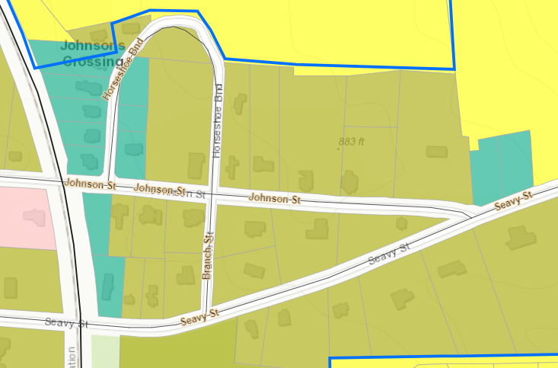

This second lot being smaller than the required lot size presents a problem for the applicant as it was not a legal lot of record at the time of this ordinance adoption, and generally an applicant cannot create their own hardship and then seek a variance.
However, it does appear to be appropriate to rezone to RH since it is within the Residential Historic District, and this will mean that the new homes must comply with the Historic District guidelines. If approved the applicant will need to seek a Certificate of Appropriateness (COA) from the HPC prior to approval of building permits.
Also, previously the lot had two homes on it and does already have two water meters and separate power and sewer hook ups.

Future Land Use
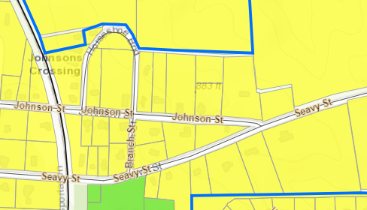

The lot shown marked above with a red “X” is located within the Residential use category as seen in yellow on a snapshot of the future land use map.
The rezoning to RH is appropriate for the future land use category.

Staff Report
The applicant is requesting a variance from the Zoning Ordinance, Section 74-85, and Residential Historic District – RH
The purpose of this district shall be to accommodate residential development located within the city's historical neighborhood overlay. This district is delineated on the official zoning map and permitted uses are in accordance with residential (R40). This zoning shall only apply to areas of the district that require no additional public infrastructure. Minimum lot size varies based on the minimum lot width at set back line. The minimum size of the primary dwelling shall be based on the average of the primary structures immediately adjacent and on the same side of the road.
The minimum lot size is 0.5 acres as shown in Sec. 74-96. District, Lot area, yard and height standards.

Planning Commission Comments and Recommendations
Planning Commission Voted unanimously to approve the subdivision and variance applications based on the following recommendations
- Recommendation was made to require the smaller .458 lot to have a 20’ minimum rear set back.
- Both houses would have side entry garage, not facing Horseshoe Bend or Johnson Street.
Applicant agreed to all recommendations

ARTICLE VI ZONING DISTRICT STANDARDS AND PERMITTED USES
Sec. 74-96. District, lot area, yard and height standards.
RH Zoning Setbacks with Arterial Corridor
- Front 15’
- Sides 20’
- Rear 40’
RH Zoning Setback with Local Corridor
- Front 15’
- Sides 20’
- Rear 0
Based on the submitted concept drawing; The Lot size of .50 would face Johnson Street an Arterial Corridor with accommodation of a 40’ Rear set back.

The smaller lot of .458 would face Horseshoe Bend, a Local Corridor without a minimum rear setback.

In consideration of this rezoning, the Mayor and Council should consider the items under Section 3.9 of the Zoning Ordinance.

- The existing land uses and zoning classification of nearby property.

- The subject property is in the City of Senoia adjacent to similarly zoned property and similar uses. The primary difference is the density and the minimum lot size.

- The suitability of the subject property for the zoned purpose.

- The lot is currently zoned R40, the neighboring lots are zoned R40 and RH

- The extent to which the property values of the subject property are diminished by the zoning restrictions.

- There are none.

- The relative gain to the public, as compared to the hardship imposed upon the individual property owner.

- There is no relative gain to the public and no significant hardship to the individual property owner.
.
- Whether the subject property has a reasonable economic use as currently zoned.

- The subject property has reasonable economic use as currently zoned.

- Whether the proposed zoning will be a use that is suitable in view of the use
- and development of adjacent and nearby property.

- The proposed zoning is reasonable.

- Whether the zoning proposal will adversely affect the existing use or usability of adjacent or nearby property.

- If rezoned to RH and developed as proposed there will be no adverse impact to the adjacent properties.

- Whether the zoning proposal is in conformity with the policies and intent of the land use element of the Comprehensive Plan.

- The future land use map shows this property as Residential.

- Whether the zoning proposal will result in a use, which will or could cause excessive or burdensome use of existing streets, transportation facilities, utilities, or schools.

- No excessive use or burden is recognized in this application.

- Whether there are other existing or changing conditions affecting the use and development of the property, which give supporting grounds for either approval or disapproval of the zoning proposal.

A. There is none.

- Whether the subject property contains jurisdictional wetlands of the United States. If so, the applicant will be required to document permit approval for the proposed development from the U.S. Army Corps of Engineers before any formal action can be taken on the zoning proposal.

- There is none.

- Whether the subject property may be large enough to qualify as a Development of Regional Impact. If so, then an application for Review must be filed with the Regional Development Center.

- The development is not big enough to qualify.

In consideration of this variance request, the Mayor and Council should use the standards set forth in section 74-300, Article XIV of the Zoning Ordinance.
“The city council shall have the following powers and duties:
To hear and decide appeals where it is alleged there is error in any order, requirement, decision, or determination made by the zoning administrator in the enforcement of this article. To authorize upon application a variance from the terms of the article, but only whereby reason of exceptional narrowness, shallowness or shape of a specific piece of property, which, at the time of adoption of this article was a lot or plat of record; or whereby reason of exceptional topographic conditions or other extraordinary or exceptional conditions of a piece of property, or whereby reason of other extraordinary or exceptional circumstances the strict application of the requirements of this article would result in practical difficulties of, or undue hardship upon, the owner of this property, provided that this relief may be granted without substantially impairing the intent and purpose of this article.
In granting a variance, the city council may attach such conditions regarding the location, character and other features of the proposed building, structure or use as it may deem advisable so that the purpose of this article will be served, public safety and welfare secured, and substantial justice done. However, the city council shall not be authorized to grant a use variance to permit a use in a district in which the use is prohibited.”

