AN ORDINANCE TO AMEND THE FATS, OILS, AND GREASE/BOD ORDINANCE OF SENOIA, GEORGIA FOR THE PURPOSE OF CLARIFYING HYDROMECHANICAL GREASE INTERCEPTOR SIZING METHODS, REPLACING TABLE OF VALUES, CORRECTING ERRORS AND TO REPEAL CONFLICTING ORDINANCES; AND FOR OTHER PURPOSES.
WHEREAS, Senoia seeks to clarify calculation methods for hydromechanical grease interceptor (HGI) sizing, replace table of values and correct errors; and
WHEREAS, Sec. 70-101(a). Purpose to control the excessive amounts of fats, oils and grease, grit, sand and other solids or viscous materials that can cause blockage and obstruction in the sanitary sewer system, causing untreated wastewater to overflow into the environment. Much of the waste material that has the potential to cause blockage or obstruction originates from commercial facilities, such as food preparation and vehicle maintenance facilities;
NOW, THEREFORE, be it ordained by the Mayor and Council of the City of Senoia, Georgia, and by the authority of same, as follows:
Article III – Sewer Use;
Division II - Non-Domestic (Industrial, Commercial, Institutional) use of public wastewater facilities; Sec. 70-101- Fats, Oils, Grease/BOD Ordinance.
ADD, a roman numeral (I) before and capitalize and center the section heading.
I. GENERAL CRITERIA
ADD, a roman numeral (II) before and capitalize and center the section heading.
II. DESIGN CRITERIA
ADD, insert as the last sentence to the last paragraph under section heading – “Design Criteria” the bold and underlined sentence below:
Still, it may be helpful to estimate approximate sizing prior to an installation, and various formulas have been developed for assessing sizing requirements. These formulas are discussed below and on the following page to assist with the planning process. FSE’s are encouraged to use these formulas to plan on the right HGI for them, but it is the sole discretion of the City of Senoia to approve or deny the size and type of grease interceptor to be installed.

DELETE, section titled “Sizing and Selecting Hydromechanical Grease Interceptors (HGI) and insert the following in its place.

III. SIZING AND SELECTING HYDROMECHANICAL GREASE INTERCEPTORS (HGI)
The following two-step sizing methodology for hydromechanical grease interceptors (HGIs) shall apply regardless whether the unit will be installed indoors or outdoors:

Step 1: Size by Flow Rate
The minimum flow rate for a passive HGI may be calculated by either using fixture volume or pipe diameter with either a one-minute or two-minute drainage period.

(1) Fixture Volume Sizing

When the final configuration of kitchen fixtures in an establishment is known, use the following formula for sizing fixtures by volume with a 75% fill factor:

(# of compartments × [L (inches)×W (inches)×H (inches)])
231 cubic inches per gallon X 0.75 = Fixture Capacity Gallons

- Fixture Capacity Gallons x 1 = one-minute drainage period (GPM)
Use a one-minute drainage period when the interceptor is installed within 20 feet of directly connected fixtures and/or has indirectly connected fixtures.
- Fixture Capacity Gallons x 0.5 = two-minute drainage period GPM)
Use a two-minute drainage period when the interceptor will be installed exterior to the building beyond 20 feet of the connected fixtures.
Example:
Three-compartment sink with each compartment being 18 x 24 x 12 inches.
(3 x [18” x 24” x 12”]) = 15,552 cubic inches (in3)
15,552 / 231 = 67.3 total fixture capacity gallons
67.3 x 0.75 = 50.4 fixture capacity after loading factor (75%)
50.4 x 1 = 50 GPM (using one-minute drainage period), or
50.4 x 0.5 = 25 GPM (using two-minute drainage period)

To determine the minimum required flow rate for the HGI, calculate the capacity of each fixture that will be connected, add the volumes together, and use the appropriate drainage period. An appropriate HGI must be certified to meet the minimum flow rate as calculated.
It is advisable to use a one-minute drainage period when the HGI will be installed in the kitchen area near the fixtures being serviced.
It is essential to use a one-minute drainage period when indirectly connected fixtures are connected to the HGI.
A two-minute retention time assumes only directly connected fixtures are routed to the HGI. A two-minute drainage period will negatively affect the total time for draining fixtures and is often a complaint of owners.

(2) Pipe Diameter Sizing

When the final configuration of kitchen fixtures in an establishment is unknown or to allow for the addition of fixtures in the future, the minimum HGI volume may be determined by the diameter of the drainage pipe leading from the establishment according to Table 1:

Table 1
Pipe Size (inches) | Full-Pipe Flow (GPM)1 | One-minute drainage period (GPM) | Two-minute drainage period (GPM)
2 | 20 | 20 | 10
3 | 60 | 75 | 35
4 | 125 | 125 | 75
5 | 230 | 250 | 125
6 | 375 | 400 | 200
2. 1/4 inch per foot based on Manning's formula with friction factor N = 0.012

- When using pipe diameter sizing and the HGI is installed inside the kitchen near the fixtures being serviced, it is advisable to use a one-minute drainage period to ensure the drainage time is not a nuisance.

- When installed in the kitchen near the fixtures being serviced and with an indirectly connected fixture, it is essential to use a one-minute drainage period.

- When installed exterior to the building, where the developed length of piping can be quite long, a two-minute drainage period will provide a satisfactory result in drainage times.

(b) Step 2: Calculate Grease Capacity
Once the minimum flow rate has been established in Step 1, calculate the minimum grease storage capacity for the HGI required for the desired pump-out frequency as follows:
=
X
X

Grease Factor from Table 2

Meals or Customers per day

Days between pump-outs

Grease Capacity Required

- To determine the correct grease factor, using Table 2, select the menu type (1 through 30), then the correct column (A through D) for whether there is a fryer and whether the establishment uses disposable or washable plates, glasses, knives, forks and spoons (flatware).

Example:
Fast food burgers and fries, with fryer, with disposable flatware, serving 300 meals per day

Grease factor from Table 2: 6C = 0.035 pounds per meal
Meals per day = 300
Days between pump-outs = 90
Grease storage capacity required is 0.035 x 300 x 90 = 945 pounds

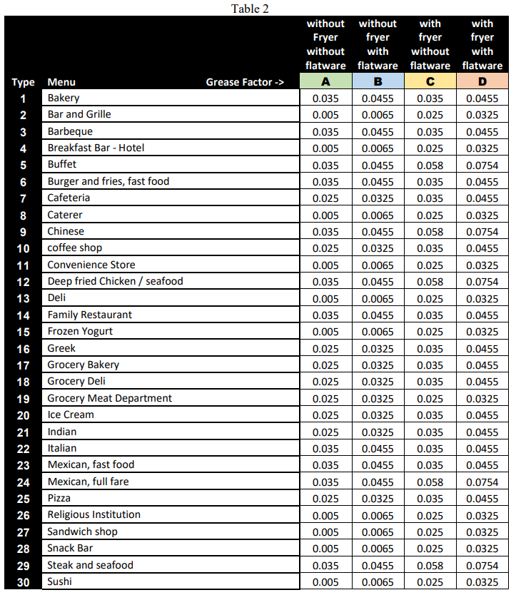
The correctly sized and selected GCD will have the minimum flow rate determined in Step 1 and the minimum grease storage capacity calculated in Step 2.
When approved by the sanitary sewer system owner, multiple GCDs may be installed in series to satisfy the minimum flow rate requirement, the minimum grease storage capacity, or both.

- Sizing for Seasonal FSE’s:
For FSEs that only operate seasonally, the following shall apply:
- During the season, the grease control device (GCD) shall be sized and maintained with the requirements of this document;
- Prior to closing for the off-season, the GCD shall be pumped out completely, cleaned, and refilled with fresh water.

ADD, new section heading with roman numeral (IV) before the table for car wash sizing

IV. SIZING AND SELECTING CAR WASH AND SAND GREASE INTERCEPTORS

ADD, a roman numeral (V), capitalize and center the section heading.
V. VEHICLE STORAGE AND SERVICING – OIL SEPARTOR AND SAND/GRAVEL/SEPARATOR

ADD, a roman numeral (VI), capitalize and center the section heading.
VI. GREASE INTERCEPTOR MAINTENANCE

ADD, a roman numeral (VII), capitalize and center the section heading.
VII. ADMINISTRATIVE REQUIREMENTS

ADD, a roman numeral (VIII), capitalize and center the section heading.
VIII. ENFORCEMENT

Article XV
Sec. 74-317. – Repeal of conflicting ordinances; validity of prior approval and actions.
All ordinances or parts of ordinances in conflict with this ordinance are hereby be repealed.
This Ordinance shall become effective upon adoption. This day of , 2023.
SENOIA, GEORGIA
CITY COUNCIL
Mayor - William “Dub” Pearman, III

__________________________________________

Attest:
By:
Lynn Carter, City Clerk
First Reading:

Second Reading:

