Staff Report City of Senoia Dina Rimi

Department of Community Development drimi@Senoia.com
Item | Public Hearing- Variance | Location | Quarters Creek
Planning Commission Date | None | Mayor and Council Date | November 16, 2020
Applicant | Leanna Petrivelli | Purpose | Reduction of buffer for a stream

Summary
Ms. Petrivelli is requesting to reduce the undisturbed buffer to 25 feet from the currentl requirement of 50’ with a 75’ impervious setback from the top of the stream bank. . | 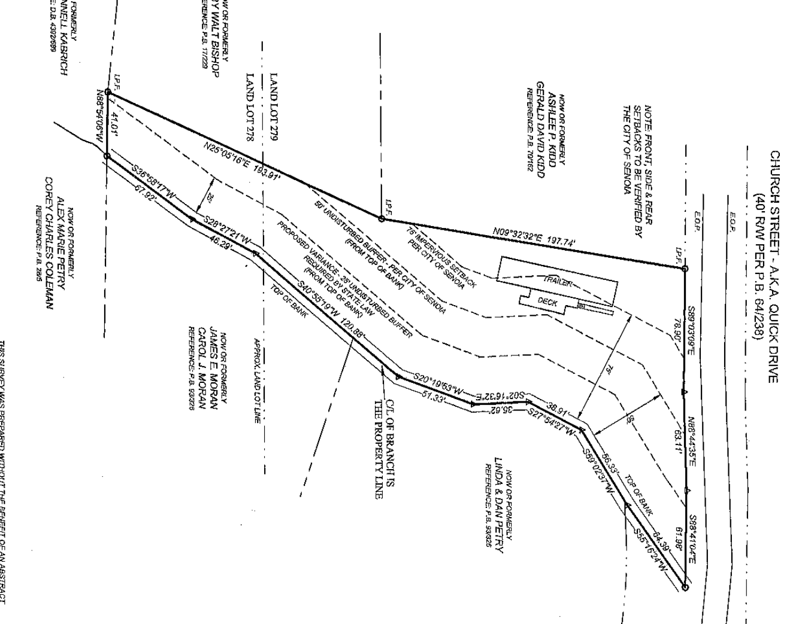

Zoning
Existing Zoning | Existing Land Use | Surrounding Zoning | Site Improvements | Size of Property
R-40 | Residential | Residential | None | .81 acres
Staff
Variance procedures. A minimum 25-foot buffer requirement is established by state law and the city has no authority to grant variances or exemptions therefrom. Otherwise, variances from the above setback requirements may be granted in accordance with the following provisions:

- Where a parcel was platted prior to the effective date of this article, and its shape, topography or other existing physical condition prevents land development consistent with this article, so as to prohibit the otherwise lawful use of the property by the owner, the mayor and council of city may grant a variance from the setback requirements hereunder, provided such variance require mitigation measures to offset the effects of any proposed land development on the parcel.

- Except as provided above, the mayor and council shall grant no variance from any provision of this article without first conducting a public hearing on the application for variance and authorizing the granting of the variance by an affirmative vote of the mayor and council. The city shall give public notice of each such public hearing in a newspaper of general circulation within city. The city shall require that the applicant post a sign giving notice of the proposed variance and the public hearing.

- The sign shall be of a size and posted in such a location on the property as to be clearly visible from the primary adjacent road right-of-way. Variances will be considered only in the following cases:

- When a property's shape, topography or other physical conditions existing at the time of the adoption of this article prevents land development unless a setback variance is granted.

- Unusual circumstances when strict adherence to the minimal setback requirements in the ordinance would create an extreme hardship. Variances will not be considered when, following adoption of this article, actions of any property owner of a given property have created conditions of a hardship on that property..

Please see the attached ordinance.

Sec. 40-325. - Land development requirements.
(a) Buffer and setback requirements. All land development activity subject to this article shall meet the following requirements:
(1) An undisturbed natural vegetative buffer shall be maintained for 50 feet, measured horizontally, on both banks (as applicable) of the stream as measured from the top of the stream bank.
(2) An additional setback shall be maintained for 25 feet, measured horizontally, beyond the undisturbed natural vegetative buffer, in which all impervious cover shall be prohibited. Grading, filling and earthmoving shall be minimized within the setback.
(3) No septic tanks or septic tank drain fields shall be permitted within the buffer or the setback.
(b) Variance procedures. A minimum 25-foot buffer requirement is established by state law and the city has no authority to grant variances or exemptions therefrom. Otherwise, variances from the above setback requirements may be granted in accordance with the following provisions:
(1) Where a parcel was platted prior to the effective date of this article, and its shape, topography or other existing physical condition prevents land development consistent with this article, so as to prohibit the otherwise lawful use of the property by the owner, the mayor and council of city may grant a variance from the setback requirements hereunder, provided such variance require mitigation measures to offset the effects of any proposed land development on the parcel.
(2) Except as provided above, the mayor and council shall grant no variance from any provision of this article without first conducting a public hearing on the application for variance and authorizing the granting of the variance by an affirmative vote of the mayor and council. The city shall give public notice of each such public hearing in a newspaper of general circulation within city. The city shall require that the applicant post a sign giving notice of the proposed variance and the public hearing. The sign shall be of a size and posted in such a location on the property as to be clearly visible from the primary adjacent road right-of-way. Variances will be considered only in the following cases:
a. When a property's shape, topography or other physical conditions existing at the time of the adoption of this article prevents land development unless a setback variance is granted.
b. Unusual circumstances when strict adherence to the minimal setback requirements in the ordinance would create an extreme hardship. Variances will not be considered when, following adoption of this article, actions of any property owner of a given property have created conditions of a hardship on that property.
(3) At a minimum, a variance request shall include the following information:
a. A site map that includes locations of all streams, wetlands, floodplain boundaries and other natural features, as determined by field survey;
b. A description of the shape, size, topography, slope, soils, vegetation and other physical characteristics of the property;
c. A detailed site plan that shows the locations of all existing and proposed structures and other impervious cover, the limits of all existing and proposed land disturbance, both inside and outside the buffer and setback. The exact area of the buffer to be affected shall be accurately and clearly indicated;
d. Documentation of unusual hardship should the buffer be maintained;
e. At least one alternative plan, which does not include a buffer or setback intrusion, or an explanation of why such a site plan is not possible;
f. A calculation of the total area and length of the proposed intrusion;
g. A stormwater management site plan, if applicable; and,
h. Proposed mitigation, if any, for the intrusion. If no mitigation is proposed, the request must include an explanation of why none is being proposed.
(4) The following factors will be considered in determining whether to issue a variance:
a. The shape, size, topography, slope, soils, vegetation and other physical characteristics of the property;
b. The locations of all streams on the property, including along property boundaries;
c. The location and extent of the proposed buffer or setback intrusion;
d. Whether alternative designs are possible which require less intrusion or no intrusion;
e. The long-term and construction water-quality impacts of the proposed variance; and

f. Whether issuance of the variance is at least as protective of natural resources and the environment.
(5) A written decision of the mayor and council on the petition for setback variance shall be deemed final. A copy of the decision shall be served on the person seeking the variance. Any person aggrieved by a final decision of the mayor and council, shall, within 30 days of receipt of the decision, have the right to petition the superior court of Coweta County for writ of certiorari.
(Ord. No. 06-05, § 1(5), 4-3-2006)

