City of Senoia, Georgia
Request for Proposals
for
Building Inspection Services

Issue Date: August 23, 2022

Issued By: City of Senoia
Office of City Manager
80 Main St Street
Senoia, GA 30263

Inquiries: Jeff Fisher, Assistant City Manager
City of Senoia
jfisher@senoia.com

Proposals Due: September 21, 2022 by 12:00 PM, EST
Bid Opening: September 21, 2022 at 12:00 PM, EST



80 Main Street
P.O. Box 310
Senoia, GA 30276
770-599-3679

A. PURPOSE

The City of Senoia is currently seeking Competitive Sealed Proposals from qualified Professional Firms to conduct building inspections pursuant to permits issued by the City of Senoia, and to remain on retainer for a period of time as shown in this invitation. Please provide a bid in accordance with the following:

B. SCOPE OF SERVICES:

Selected Firm is to conduct residential and commercial building inspections for compliance with the Construction Codes that have been adopted and amended by the State of Georgia Department of Community Affairs, and as amended by the City of Senoia, in effect for the year 2022. These codes are listed as follows:
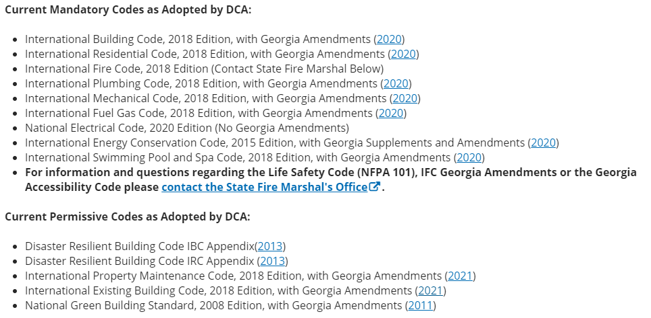

The selected Company is to conduct the inspections by qualified inspectors, certified by ICC (or equivalent) in the area of inspection in which they are responsible in conducting. Names and qualifications of the inspectors are to be included with the proposal.

All of the structures will be within the City Limits of Senoia and the term of contract will be for a 4-year limit, with a 1-year extension if agreed upon by both parties.

This is a sealed bid, competitive bid and must be provided by as shown in section B – Schedule Information. Your written bid must contain the intended scope of work and a cost per hour for the inspections, to include travel time to and from the site.

The City of Senoia will determine which inspections are to be performed by the professional Firm and will push out that information in a format and time frame agreed upon by both parties.

C. SCHEDULE INFORMATION

This RFP has been issued on August 23, 2022. All Firms interested in submitting a proposal MUST SUBMIT all addendums if applicable with their proposal. There will not be a pre-bid conference. It is the Proposers responsibility to tract this bid process. All documents including any addendums will be posted on the City of Senoia’s website www.senoia.com under bid opportunities, Building Inspection Services.

- Proposals shall be submitted by the RFP Submittal Deadline September 21, 2022
- by 12:00 PM EST.

- All questions regarding this solicitation must be submitted in writing via the provided email. Questions will be answered by issuance of an addendum and posted on the City website at www.senoia.com. The last day for questions is September 2, 2022 at 12:00 PM EST.

- The Proposer shall submit the proposal no later than September 21, 2022 at 12:00 PM EST at which time all proposals will be opened. Proposals received later than the deadline will not be considered.

- Prices and quotations included in the proposal shall remain firm for not less than one hundred twenty (120) calendar days from proposal deadline stated above.

- The City shall not be liable for any costs associated with the preparation of responses to this solicitation; therefore, all costs shall be borne by the Proposer.

- There will not be a pre-proposal conference. All prospective Proposers should review the RFP document and all Attachments and submit all questions and/or requests for additional information by the deadline of September 2, 2022 at 12:00 PM EST.

- It is the intent and purpose of the City that this solicitation promotes competition. It shall be the Proposer’s responsibility to advise Harold Simmons, City Manager, in writing, if any language or requirements, or any combination thereof, inadvertently restricts or limits this solicitation to a single source. Such notification shall be submitted in writing, and must be received by the City Manager at least five calendar (5) days prior to proposal receipt date. A review of such notification shall be made by the City of Senoia.

- Prior to submitting a proposal, each Proposer shall carefully examine the RFP document, study and thoroughly familiarize himself/herself with the specifications/requirements of the RFP and the Contract Documents and notify the City of any conflicts, errors, or discrepancies.

- By submission of a proposal, the Proposer guarantees that all goods and services meet the requirements of the RFP during the contract period.

- Failure to submit all required information may be determined as a non-responsive proposal.

12. Any Proposer may withdraw its proposal prior to the closing time for the receipt of proposals. Correction or withdrawal of inadvertently erroneous proposals before or after the opening date, or cancellation of awards or contracts based on such mistakes, may be permitted subject to the following:

- Mistakes discovered by the Proposer before proposal opening may be corrected by modification or withdrawal and resubmission by submitting written notice to the City Manager’s Office prior to the time set for proposal opening.
- After proposal opening, no changes in prices or other provisions of proposals, which are prejudicial to the interest of the City, shall be permitted.
- Except as otherwise allowed by law, all decisions to permit the correction or withdrawal of proposals, or to cancel awards, or contracts, after award but prior to performance shall be supported by a written determination made by the City Manager’s Office.

Written responses to all written inquiries received by 12:00 PM ET, September 2, 2022 will be posted on the City’s website at www.senoia.com under bid opportunities, Building Inspection Services as an addendum. It is the Proposer’s responsibility to follow this bid process so that they will be aware of all addenda being posted prior to bid opening. Acknowledgement of all addenda is required. No City staff or other officials associated with this RFP should be contacted regarding this RFP other than the City Official named below Doing so may result in disqualification.

All inquiries regarding this RFP Must be in writing via email and addressed to:

Jeff Fisher, Assistant City Manager
jfisher@senoia.com

An original, five (5) copies and one (1) digital copy of this RFP are to be submitted to:

Harold Simmons
Senoia City Manager
80 Main Street
Senoia, Georgia 30276

Proposals must be submitted no later than 12:00 PM EST, September 21, 2022. Proposals must be received in a sealed envelope or container marked “Competitive Sealed Proposals for Building Inspection Services.”

No proposal will be received or accepted after the above specified date and time of the proposal opening. Proposals submitted after the designated date and time will be deemed invalid and returned unopened to the proponent.

D. INSTRUCTIONS FOR PROPOSALS

    - Proposals are to be prepared simply and, in a manner, designed to provide the City with a straightforward presentation of the Proposer’s capability to satisfy the requirements of this RFP. The Proposer’s proposal must, therefore, follow the RFP format, utilizing the bid sheet that is contained in this document.

    - The Proposer shall make its proposal in the official name of the entity or individual under which business is conducted (showing official business address).

    - The Proposer shall include all applicable requested information and is encouraged to include any additional information the Proposer wishes to be considered. If the proposal includes any comments over and above the specific information requested in our RFP, the Proposer shall include this information as a separate appendix to the proposal.

    - The Proposer shall clearly write in ink or type-write all prices and quotations, and complete the bid sheet in its entirety.

    - Each Proposer shall fully acquaint itself with conditions relating to the scope and restrictions attending the execution of the work contemplated under this RFP. The failure or omission of a Proposer to acquaint itself with existing conditions shall in no way relieve the Proposer of any obligation with respect to this RFP or any agreement reached with the City.

E. EVALUATION OF BIDS

Awarding of the bid shall be based upon, but not limited to, the factors listed below, not necessarily in the order of their importance:

- Price of bid
- Quality of the proposal
- Prior business experience with the bidder
- Ability of the bidder to fulfill contract and specifications
- Reputation of bidder and service to other local municipalities/clients
- Responsiveness to specifications and special terms and conditions set forth in this Request for Proposal and attachments

F. GENERAL CONDITIONS

Upon submission of a bid, the bidder hereby certifies on behalf of his company or organization that:

- This bid is genuine and not made in the interest of, or on behalf of, an undisclosed person, firm or corporation.
- This bid is not submitted in conformity with any agreement or rules of any group, association, organization or corporation.
- The bidder has not directly or indirectly induced or solicited any other bidder to submit a false or sham bid.
- The bidder has not solicited or induced any person, firm or corporation to refrain from bidding.
- The bidder has not sought by collusion to obtain for itself any advantages over any other bidder or over the City of Senoia.

G. EQUAL OPPORTUNITY

The City of Senoia prohibits discrimination on the basis of race, color, gender, religion, national origin, or disability in connection with employment of any person, or the award of any contract with the corporation. The City of Senoia will provide equal opportunities without regard to race, color, gender, religion, national origin, or disability, by requiring that any bank doing business with the corporation provide equal opportunity to persons and businesses employed by, or contracting with the supplier of products and services to the Corporation.

H. ACCESS TO PUBLIC RECORS

Each vendor should give specific attention to the identification of those portions of its proposal that it considers confidential, proprietary commercial information or trade secrets, and provide justification as to why such materials, upon request, should not be disclosed.

I. GEORGIA SECURITY AND IMMIGRATION COMPLIANCE ACT: E-VERIFY AND SAVE PROGRAM

The City of Senoia participates in the Georgia Security and Immigration Compliance Act with regard to Contractors and Subcontractors. The Act is explained in detail in this document. Additionally, there are three documents included that must be completed and returned to the City of Senoia with your bid package, as applicable. These are:

- Contractor Affidavit and Agreement
- Subcontractor Affidavit – if applicable
- Sub-subcontractor Affidavit – if applicable

Failure to return the completed documents, if required, shall result in disqualification of the bid in its entirety

The undersigned Proposer has read and understands the provisions contained herein and agrees to be bound by same. Please sign below to acknowledge you have read and understand the RFP requirements.

PROPOSER
________________________
Name of Firm

By: _________________________

Name: ______________________
Title: _______________________



City of Senoia Bid Form
Building Inspections Services
Due Date:

Company/Firm Name: _______________________________

Address: _______________________________

_______________________________

Contact Number: _______________________________

Part I. Fee Proposal for Project

Project | Hourly Rate | Remarks
Building Inspections

Part II. Exceptions and Reservations

Exceptions and Reservations regarding the proposal include: (Leave Blank if None)

Prepared By: _____________________________

(Print Name)

_____________________________ _________
(Signature) Date
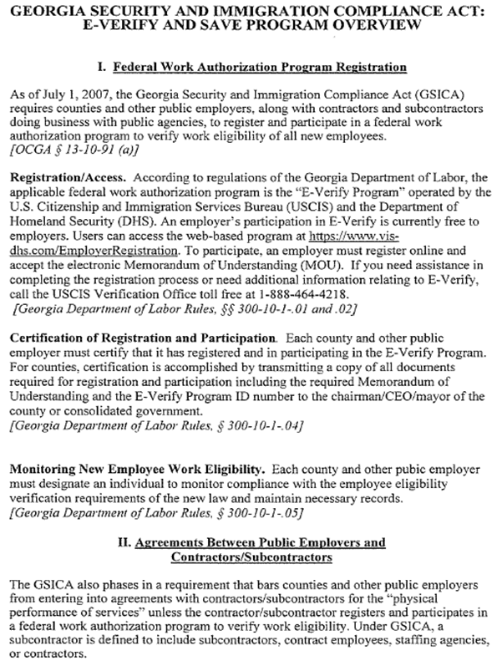

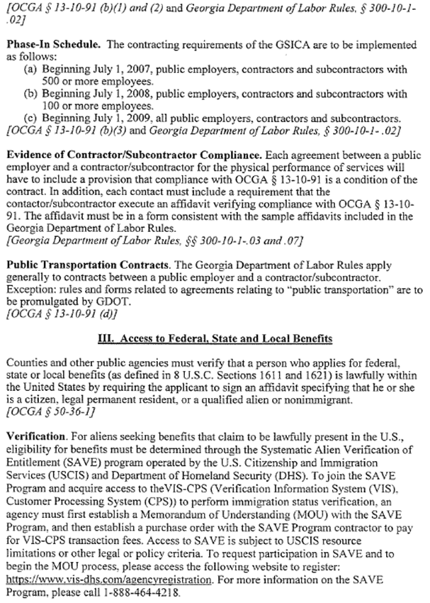

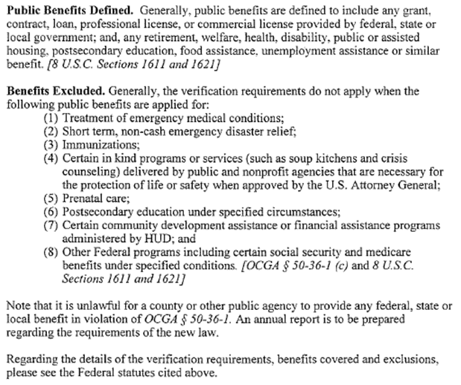

Contractor Affidavit under O.C.G.A. § 13-10-91(b)(1)

By executing this affidavit, the undersigned contractor verifies its compliance with O.C.G.A. § 13-10-91, stating affirmatively that the individual, firm or corporation which is engaged in the physical performance of services on behalf of ________________________________________________________________ has registered with, is authorized to use and uses the federal work authorization program commonly known as E-Verify, or any subsequent replacement program, in accordance with the applicable provisions and deadlines established in O.C.G.A. § 13-10-91. Furthermore, the undersigned contractor will continue to use the federal work authorization program throughout the contract period and the undersigned contractor will contract for the physical performance of services in satisfaction of such contract only with subcontractors who present an affidavit to the contractor with the information required by O.C.G.A. § 13-10-91(b). Contractor hereby attests that its federal work authorization user identification number and date of authorization are as follows:

__________________________________ _______________________
Federal Work Authorization User Identification Number Date of Authorization

__________________________________ ______________________________________
Name of Contractor Name of Project or Services

____________________________________________________________________________
Name of Public Employer

I hereby declare under penalty of perjury that the foregoing is true and correct.
Executed on _____________________________, 20____ in _________________.

____________________________________________
Signature of Authorized Officer or Agent

____________________________________________
Printed Name and Title of Authorized Officer or Agent

SUBSCRIBED AND SWORN BEFORE ME ON THIS THE ______ DAY OF ____________________________, 20_____.

____________________________________
NOTARY PUBLIC

My Commission Expires: ___________________________________________.

Subcontractor Affidavit under O.C.G.A. § 13-10-91(b)(3)

By executing this affidavit, the undersigned subcontractor verifies its compliance with O.C.G.A. § 13-10-91, stating affirmatively that the individual, firm or corporation which is engaged in the physical performance of services under a contract with _________________________________________________ (Contractor) on behalf of _____________________________________________ (Public Employer) has registered with, is authorized to use and uses the federal work authorization program commonly known as E-Verify, or any subsequent replacement program, in accordance with the applicable provisions and deadlines established in O.C.G.A. § 13-10-91. Furthermore, the undersigned subcontractor will continue to use the federal work authorization program throughout the contract period and the undersigned subcontractor will contract for the physical performance of services in satisfaction of such contract only with sub-subcontractors who present an affidavit to the subcontractor with the information required by O.C.G.A. § 13-10-91(b). Additionally, the undersigned subcontractor will forward notice of the receipt of an affidavit from a sub-subcontractor to the contractor within five business days of receipt. If the undersigned subcontractor receives notice of receipt of an affidavit from any sub-subcontractor that has contracted with a sub-contractor to forward, within five business days of receipt, a copy of such notice to the contractor. Subcontractor hereby attests that its federal work authorization user identification number and date of authorization are as follows:

__________________________________ ______________________________
Federal Work Authorization User Identification Number Date of Authorization

__________________________________ ______________________________________
Name of Subcontractor Name of Project or Services

____________________________________________________________________________
Name of Public Employer

I hereby declare under penalty of perjury that the foregoing is true and correct.
Executed on _____________________________, 20____ in __________________.

_________________________________ ______________________________________
Signature of Authorized Officer or Agent Printed Name & Title of Authorized Officer or Agent

SUBSCRIBED AND SWORN BEFORE ME ON THIS THE ¬¬¬______ DAY OF ____________________________, 20_____.

____________________________________
NOTARY PUBLIC

My Commission Expires: ___________________________________________.

Sub-subcontractor Affidavit under O.C.G.A. § 13-10-91(b)(4)

By executing this affidavit, the undersigned sub-subcontractor verifies its compliance with O.C.G.A. § 13-10-91, stating affirmatively that the individual, firm or corporation which is engaged in the physical performance of services under a contract with ______________________________________________ (Subcontractor or Sub-subcontractor with whom subcontractor has privity of contract) and ________________________________ Contractor) on behalf of _____________________________________________ (Public Employer) has registered with, is authorized to use and uses the federal work authorization program commonly known as E-Verify, or any subsequent replacement program, in accordance with the applicable provisions and deadlines established in O.C.G.A. § 13-10-91. Furthermore, the undersigned sub-subcontractor will continue to use the federal work authorization program throughout the contract period and the undersigned sub-subcontractor will contract for the physical performance of services in satisfaction of such contract only with sub-subcontractors who present an affidavit to the sub-subcontractor with the information required by O.C.G.A. § 13-10-91(b). The undersigned sub-subcontractor shall submit, at the time of such contract, this affidavit to _____________________________________ (Subcontractor or Sub-subcontractor with whom subcontractor has privity of contract). Additionally, the undersigned sub-subcontractor will forward notice of the receipt of any affidavit from a sub-subcontractor to ___________________________________________ (Subcontractor or Sub-subcontractor with whom the subcontractor has privity of contract). Sub-subcontractor hereby attests that its federal work authorization user identification number and date of authorization are as follows:

__________________________________ _______________________
Federal Work Authorization User Identification Number Date of Authorization

__________________________________ ______________________________________
Name of Sub-subcontractor Name of Project

____________________________________________________________________________
Name of Public Employer

I hereby declare under penalty of perjury that the foregoing is true and correct.
Executed on _____________________________, 20____ in __________________________.

_________________________________ ______________________________________
Signature of Authorized Officer or Agent Printed Name & Title of Authorized Officer or Agent

SUBSCRIBED AND SWORN BEFORE ME ON THIS THE ______ DAY OF ____________________________, 20_____.

____________________________________
NOTARY PUBLIC

My Commission Expires: ______________________________________________.

