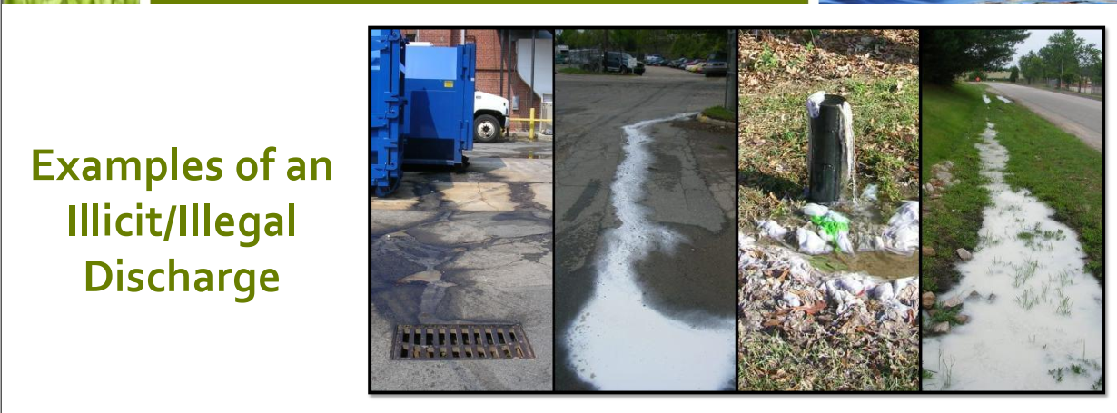

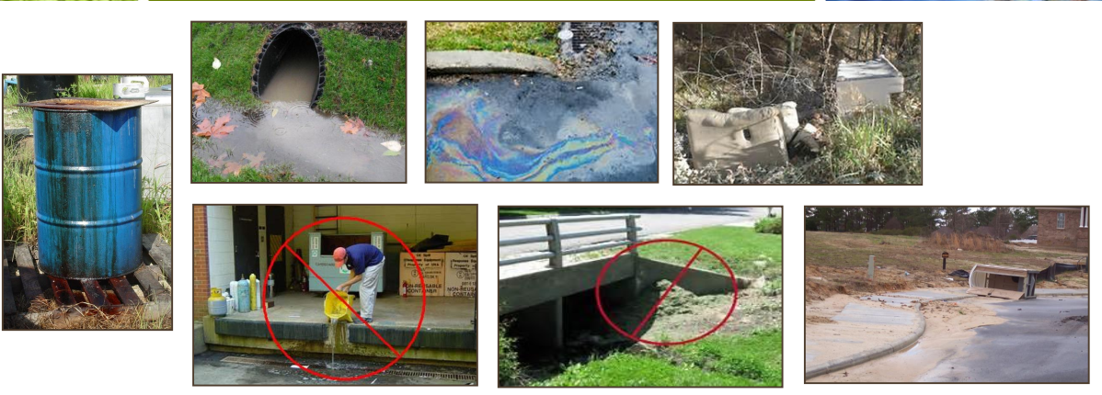

TO REPORT ILLICIT/ILLEGAL DUMPING CONTACT

BO CUMMINGS AT 678-857-9880